Initial Analysis

Connor Vaughan

Looking at the unemployment rate by gender it is interesting to see that it use to be higher for women but around 1980 it began to switch and has been higher for men for the majority of the past 3 decades. The chart graphing unemployment by race shows a large disparity between the unemployment rate of different races. The cause of this drastic difference is hard to grasp but mostly comes down to social issues. There is some difference between the unemployment rates of different age groups but this is not that surprising because individuals with more experience are able to find jobs easier. Although there is some difference in the unemployment rate across the demographics they all follow the same trends over time. During the early 1980s the U.S. entered a recession which caused the unemployment rate to spike. In the late 90s and early 2000s the economy was doing very well, this was time period was known as the dot com boom, and the unemployment rate was historically low. After the dot com bubbble burst the unemployment rate rose slightly across all demographics but then began to fall again. Then, in 2007, the housing crisis hit and the economy went into the worst recession since the great depression. Fortunatley, the U.S. has mostly recovered from that in terms of jobs and the unemployment rate is back to being historically low. It is unlikely that the unemployment rate is going to stay this low for much longer and is most likely goig to rise in the coming years.

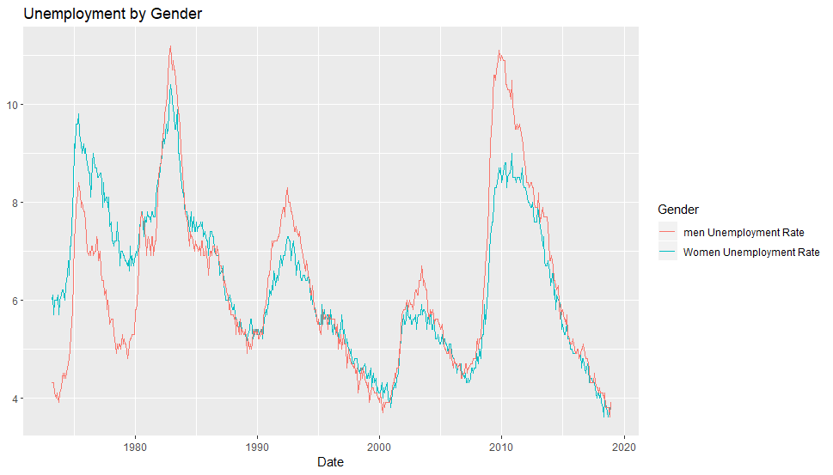

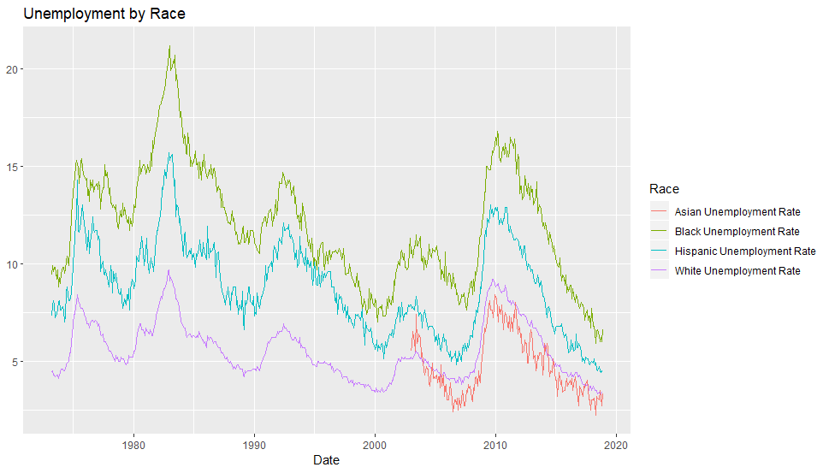

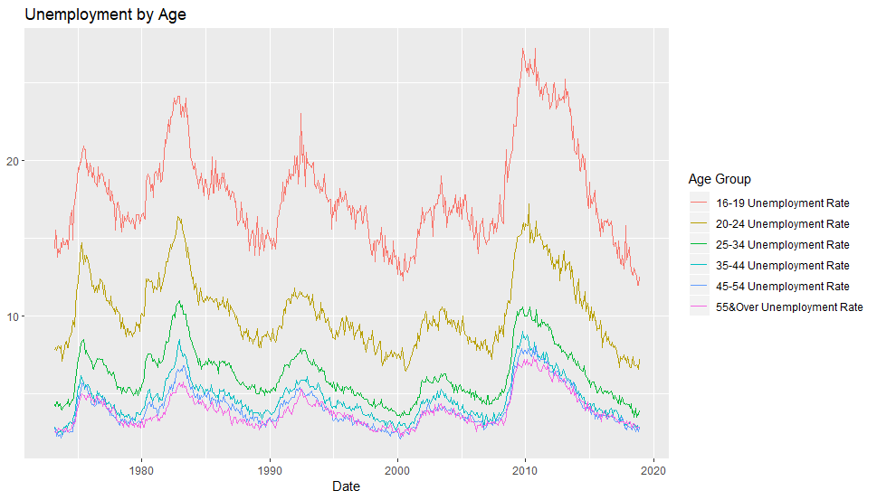

|  |  |  |  |
| --- | --- | --- | --- |
| Demographic | Mean | Min | Max |
| Women | 6.35 | 3.6 | 10.4 |
| Men | 6.30 | 3.6 | 11.2 |
| Black | 11.97 | 5.9 | 21.2 |
| Hispanic | 8.82 | 4.4 | 15.7 |
| White | 5.54 | 3.3 | 9.7 |
| Asian | 4.78 | 2.2 | 8.4 |
| 16-19 | 17.86 | 12 | 27.2 |
| 20-24 | 10.30 | 6.5 | 17.2 |
| 25-34 | 6.22 | 3.5 | 11 |
| 35-44 | 4.67 | 2.4 | 9 |
| 45-54 | 4.14 | 2.1 | 8.1 |
| 55 & Over | 3.93 | 2.3 | 7.4 |